eTime Approval Process for Supervisors - Employee Self Service/HRIS

As a designated supervisor, an e-mail message will be received after a student employee completes and submits their eTime document (electronic time document) for approval. The eTime Document replaces the hard copy time document, allows student employees to enter time on-line, and automates workflow (e-mail notification) for the approval process.

E-mail Notification:

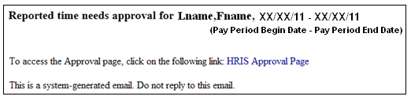
Note: E-mail notification includes HRIS Link (i.e., HRIS Approval Page).

Zimbra Filters: http://www.k-state.edu/its/zimbra/help/create_filter.html

To approve or reject eTime entry:

1) Access HRIS: https://hris.k-state.edu/ and login using your K-State eID and password.

2) Select … Manager Self Service > Time Management > Approval List

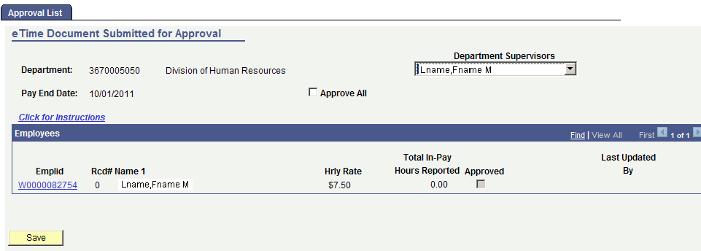

3) Approve or Reject Reported Hours

A. Select Department Supervisor, if appropriate
B. Approve or Reject Reported Hours

To Approve Hours
… turn on the Approve All check box, or
… turn on the Approved check box for each employee, or
… click on EmplID (Employee ID) to access/view eTime document for employee.

3) Approve or Reject Reported Hours continued …

To Reject Hours
… click on EmplID to access/view eTime document and select the
reject button to identify reason.

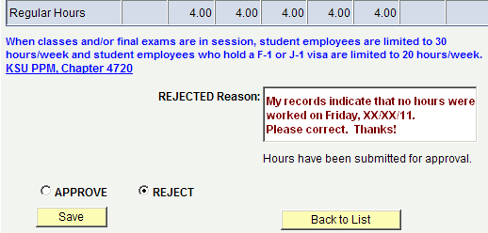

4) Select Save and Sign Out

Additional Details
Please approve time entry for your student employees each pay period prior to 5:00 p.m. on the Monday following pay period end date for a timely paycheck. Pay Periods and Pay Dates: http://www.k-state.edu/hr/paydates.html

Department Supervisors: Select yourself or another department supervisor from the list.

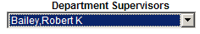

After supervisor is selected, employees who report to selected supervisor will appear and those who have completed and submitted their eTime document for approval will appear with recorded hours.

Approve or Reject Reported Hours

After approving hours, an e-mail notification from HRIS will be sent to the employee and the supervisor. Also, the hours will be automatically forwarded to begin the paycheck process. Those with no hours reported cannot be approved … check box will appear grey.

After rejecting hours, an e-mail notification from HRIS will be sent to the employee and the supervisor indicating the needed adjustment. The employee will be responsible for making the adjustment and resubmitting for approval prior to the on-line entry deadline.

Save and Sign out of HRIS before closing browser.
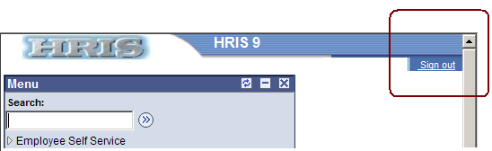

Note: If an employee does not appear on the approval list or approval needs to be processed after the deadline, please contact your department personnel specialist for instructions.

