eTime Entry for Student Employees - Employee Self Service/HRIS
The eTime Entry page in Employee Self Service/HRIS replaces the hard copy time document for student employees and allows on-line entry each day, week, or pay period. To record time worked on-line, follow these steps:

- Access Employee Self Service/HRIS: https://hris.k-state.edu/ and login using your K-State eID and password.
- Access eTime Document (On-line Entry Page):
Employee Self Service > Time Reporting > Time Entry
- Enter actual hours worked each day, week, or pay period.
- After recording hours, click on
Save for Later (allows further access to add and/or update hours)
or
Submit for Approval (time entry complete - no further access to add and/or update hours).
- Sign out of Employee Self Service/HRIS before closing browser.

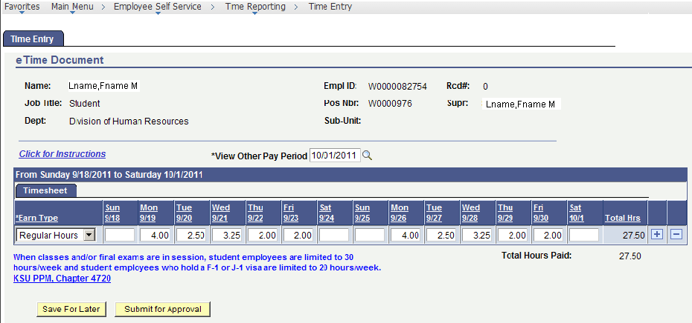

On-Line Entry Timelines

On-line entry will be limited to one pay period at a time to avoid confusion. The first Monday of each pay period the eTime Document (on-line entry page) for the prior pay period will close at 5:00 p.m. and the eTime Document for the current pay period will open at 5:01 p.m.
Pay Periods/Pay Dates: http://www.k-state.edu/hr/hris/hris-tables-pay.html
Employee Self Service and Manager Self Service Pages Open/Close

Pay Period: 10/16/11 – 10/29/11
Time Entry Page Opens: Monday, 10/17/11, 5:01 p.m.
Time Entry Page Closes: Monday, 10/31/11, 5:00 p.m.

Pay Period: 10/30/11 – 11/12/11
Time Entry Page Opens: Monday, 10/31/11, 5:01 p.m.
Time Entry Page Closes: Monday, 11/14/11, 5:00 p.m.

Pay Period: 11/13/11 – 11/26/11
Time Entry Page Opens: Monday, 11/14/11, 5:01 p.m.
Time Entry Page Closes: Monday, 11/28/11, 5:00 p.m.

eTime Entry Page
eTime Entry page via Employee Self Service/HRIS replaces the hard copy time document and allows hours worked to be recorded on-line each day, week, or pay period. After recording hours worked, select the Save for Later or Submit for Approval button.
Save for Later: Saves the recorded hours and allows user further access to add and/or update hours. This button does not forward hours to supervisor/approver for approval.

Submit for Approval: This button saves the hours recorded and forwards hours for approval. Once Submit for Approval has been selected, hours cannot be changed within this page.

After Submit for Approval has been selected, the supervisor and the employee will be notified via e-mail from HRIS. The supervisor is responsible for approving or rejecting the recorded hours.

Approved Hours
Approved hours will be forwarded to payroll for processing and the employee and supervisor will be notified via e-mail from HRIS.

Rejected Hours
Rejected hours will reactivate the employee’s eTime Document for correction and the employee and supervisor will be notified via e-mail from HRIS. The employee is responsible for making the adjustment quickly and resubmitting for approval prior to the deadline for a timely paycheck.

Late Time Entries/Policy
Those who miss the deadline for entering hours for the current pay period will need to contact their supervisor and/or department personnel specialist for instructions.

Multiple Positions
For those who have multiple positions, a page with all available positions will appear. Select the appropriate position and record hours. If multiple positions should be present and only one position appears, please contact your supervisor or department personnel specialist for instructions.
Recording Time Worked
Earn types are used to designate the type of hours recorded. Earn Type, Regular Hours, will automatically display on the page. Earn Type, Overtime Hours, may be added when appropriate.

Regular Hours: Used to record the first 40 hours worked each week.
Recording hours worked in quarter hour increments.
Minutes Worked Hours Recorded
0-07 .00
08-22 .25
23-37 .50
38-52 .75
53-67 1.00

Examples:
If you work 4 hours plus 5 minutes … record 4.00.
If you work 4 hours plus 20 minutes … record 4.25.
If you work 4 hours plus 27 minutes … record 4.50.

If you work 4 hours plus 45 minutes … record 4.75.
Overtime Hours: Used to record any hours worked that exceed 40 hours for the work week. Always secure prior approval from your supervisor before working any hours that exceed 40 hours for the week. To add a row for
overtime hours, select the “ + “ button on the right side of the page.

Overtime compensation is 1.5 times hourly wage for all hours over 40.
Resources

K-State Policies and Procedures: http://www.k-state.edu/policies/ppm/

Chapter 4220, Hours of Work, Overtime and Compensatory Time
Chapter 4720, Hourly Student Employees

Hourly Student Employee Orientation:
http://www.k-state.edu/hr/hris/Hourly_Student.pdf

View Other Pay Period
Previous pay periods may be viewed by accessing the drop down edit box at the top of the page.
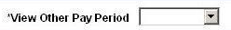
Error Messages:
Edits have been built-in to prevent errors. The following messages appear when

…FLSA rules not followed.

Message: Regular hours not over 40. You may not add overtime hours prior to being in work status over 40 hours.

Message: Hours entered over 40. To record any hours worked greater than 40 within the work week, add a row ( + ) and select Overtime Hours.

… greater than 24 hours/day or quarter hour increments are not recorded.

Message: Time must be entered in quarter hour increments between 0 – 24.

… employee’s department is not participating in electronic time entry process.

Message: Your department is not participating in eTime Entry Process in Employee Self Service at this time. If you have questions, please contact your departmental personnel specialist. Thank You

Questions:
Please contact your supervisor and/or department personnel specialist if you have questions regarding this process.

